**Composite Design Pattern**

**Assignment - 3**

Name - Heet Dobariya Roll No. - 22BCP177 Group - G5

* **Program :** Implement composite design pattern for the car as composite component.
* **UML Diagram :**

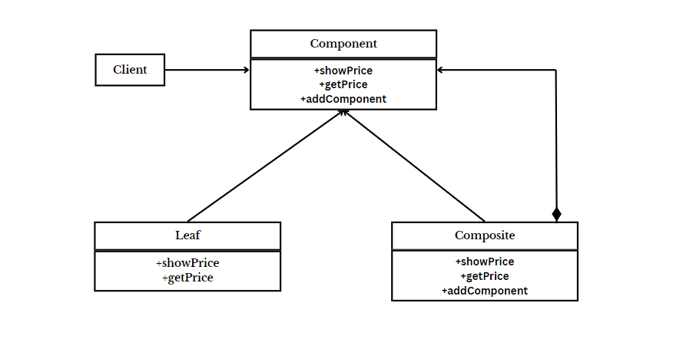

* **Tree Diagram :**

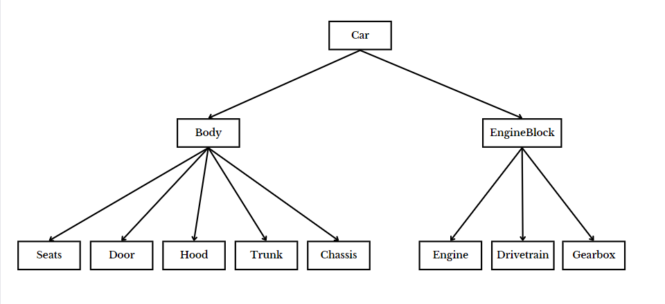

* **Code :**

import java.util.ArrayList;

import java.util.List;

interface Component

{

void showPrice();

int getPrice();

}

class Leaf implements Component

{

int price;

String name;

Leaf(String name, int price)

{

this.price = price;

this.name = name;

}

@Override

public void showPrice()

{

System.out.println("Leaf -> "+name+" : "+price);

}

@Override

public int getPrice()

{

return price;

}

}

class Composite implements Component

{

String name;

List<Component> components = new ArrayList();

public Composite(String name)

{

super();

this.name = name;

}

public void addComponent(Component com)

{

components.add(com);

}

@Override

public int getPrice()

{

int p=0;

for(Component c:components)

{

p += c.getPrice();

}

return p;

}

@Override

public void showPrice()

{

System.out.println("Composite -> "+name+" : Price -> "+getPrice());

System.out.println("Leaf of " +name);

for(Component c:components)

{

c.showPrice();

}

}

}

public class CarFactory

{

public static void main(String[] args)

{

Component seats = new Leaf("Seats", 40000);

Component chassis = new Leaf("Chassis", 500000);

Component doors = new Leaf("Doors", 100000);

Component trunk = new Leaf("Trunk", 20000);

Component hood = new Leaf("Hood", 50000);

Component engine = new Leaf("Engine", 500000);

Component drivetrain = new Leaf("Drivetrain", 700000);

Component gearbox = new Leaf("Gearbox", 350000);

Composite body = new Composite("Body");

Composite engineBlock = new Composite("Engine Block");

Composite car = new Composite("Car");

body.addComponent(seats);

body.addComponent(chassis);

body.addComponent(doors);

body.addComponent(trunk);

body.addComponent(hood);

engineBlock.addComponent(engine);

engineBlock.addComponent(drivetrain);

engineBlock.addComponent(gearbox);

car.addComponent(body);

car.addComponent(engineBlock);

car.showPrice();

}

}

* **Output :**

